
BACHELOR OF SCIENCE IN SOFTWARE DEVELOPMENT
FINAL YEAR PROJECT
INTEGRATED CAMPUS MANAGEMENT SYSTEM
(KCA STUDENT APP)
BY
22/04168
DOANE WELLINGTONE OGWENO

2204168@students.kcau.ac.ke

SYSTEM DESIGN SPECIFICATION DOCUMENT
SUBMITTED IN PARTIAL FULFILMENT FOR THE REQUIREMENTS FOR THE AWARD OF A DEGREE IN SOFTWARE DEVELOPMENT

PRESENTED TO: DR RUFUS GIKERA

DECLARATION

I declare that this project is my original work and has not been presented in any other college or University for the award of a Diploma or Degree.
Student
Name ……………………………………………….. Date…………………………………………..
Signature………………………………………………

Supervisor
Name ……………………………………………….. Date…………………………………………..
Signature………………………………………………

Table of Contents
DECLARATION 2
ABSTRACT 5
1. INTRODUCTION 5
1.1 Purpose 5
1.2 Scope 6
2. SYSTEM OVERVIEW 6
2.1 System Description 6
2.2 System Architecture 6
3. SYSTEM MODULES 7
3.1 Student Portal module 7
3.2 Virtual Campus module 8
3.3 Complaint management system 9
3.4 Fee billing and payment system 10
4. SYSTEM DESIGN 10
4.1 Database Design 10
4.2 Data Flow Diagram 11
4.3 Entity Relationship Diagram 11
4.4 User interface Diagram 11
5. TECHNOLOGY STACK 13
6. DEVELOPMENT METHODOLOGY 13
6.1 Agile Methodology 13
7. IMPLEMENTATION PLAN 14
7.1 Project Phases 14
7.2 Project Schedule 17
8. SECURITY AND PRIVACY 17
9. TESTING STRATEGY 21
10. MAINTENANCE AND SUPPORT 22
11. BUDGET AND RESOURCES 24
12. CONCLUSION 24
13. REFERENCES 24

ABSTRACT
The Integrated Campus Management System (ICMS) is a comprehensive digital solution designed to streamline key administrative and academic functions at KCA University. The system will integrate four major modules—Student Portal, Virtual Campus, Complaint Management, and Fee Billing—into a unified platform accessible through mobile interfaces. The ICMS aims to enhance institutional efficiency, transparency, and communication by automating routine tasks and facilitating real-time access to academic and financial data.
Through the Student Portal module, learners can register, access course materials, and view academic progress. The Virtual Campus feature fosters online learning and engagement between students and lecturers, while the Complaint Management System will provide an efficient channel for students to lodge and track grievances. The Fee Billing module automates invoicing, payments, and receipt generation, ensuring accurate and timely financial management.
The project adopts an object-oriented design methodology using the waterfall development model, emphasizing structured phases of requirement gathering, system design, implementation, testing, and deployment. The backend will be powered by a relational database, MySQL, while the frontend utilizes Android Studio and visual studio code for mobile development.
Overall, the ICMS will bridge existing gaps in communication, data management, and service delivery within the university. It is envisioned to promote digital transformation, reduce paperwork, and improve user satisfaction by offering a centralized, secure, and scalable University management environment.

INTRODUCTION

Purpose

This document outlines the detailed design and development specifications for the Integrated Campus Management System (ICMS) at KCA University. It serves as a technical blueprint for developers, system analysts, and administrators, providing an overview of the system’s architecture, modules, data design, software and hardware requirements, and implementation strategy.

Scope
The ICMS integrates four major university functions into one platform:
- Student Portal
- Virtual Campus
- Complaint Management System
- Fee Billing and Payment System
The system will streamline student engagement, automate administrative processes, and enhance transparency in service delivery at KCA University. It will be accessible via an Android mobile application.

SYSTEM OVERVIEW

System Description
The ICMS will be a multi-tier client-server system with:
- Frontend Layer: Android app.
- Backend Layer: RESTful API built using Python Django.
- Database Layer: Centralized MySQL database.
- Integration Layer: Payment gateway (M-Pesa API) and notification services (Firebase Cloud Messaging)

System Architecture
Presentation layer
Android app
Application layer
Python Django backend APIs
Data layer
MYSQL database
This architecture ensures modularity, scalability, and secure data exchange between clients and the server.

SYSTEM MODULES

Student Portal module

The portal provides students with access to academic information, personal details, grades, self services and university announcements.
Key Features:
- User login and request for admission
- View course list and grades
- Select course units
- Request for deferment and inter faculty transfer
- Receive notifications and announcements
- Update profile information

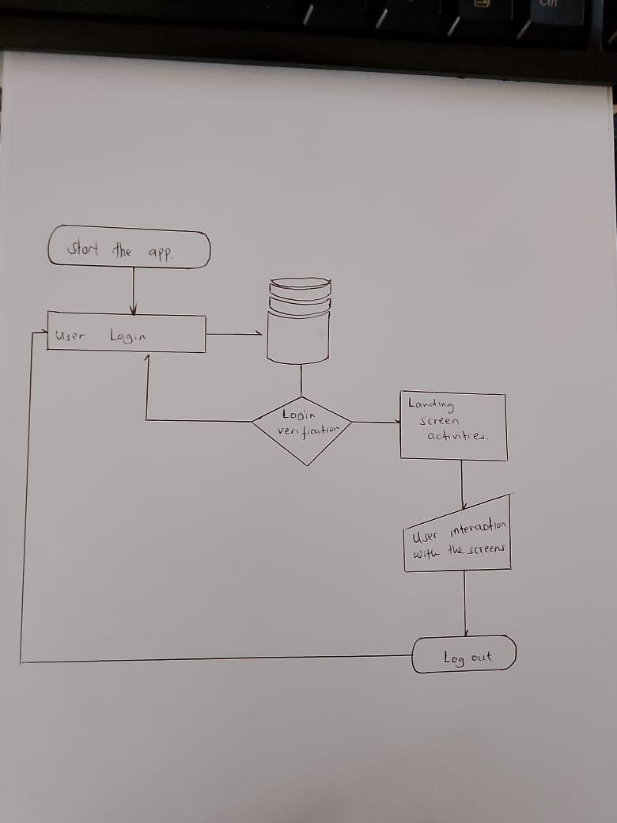

Virtual Campus module

This module will facilitate online learning and virtual interaction between lecturers and students. It will also have automated online class session monitor to automatically check attendance and single out the active students
Key Features:
- Virtual class sessions and attendance
- Course material uploads/downloads
- Real-time chat/discussion forums
- Assignment submission and grading

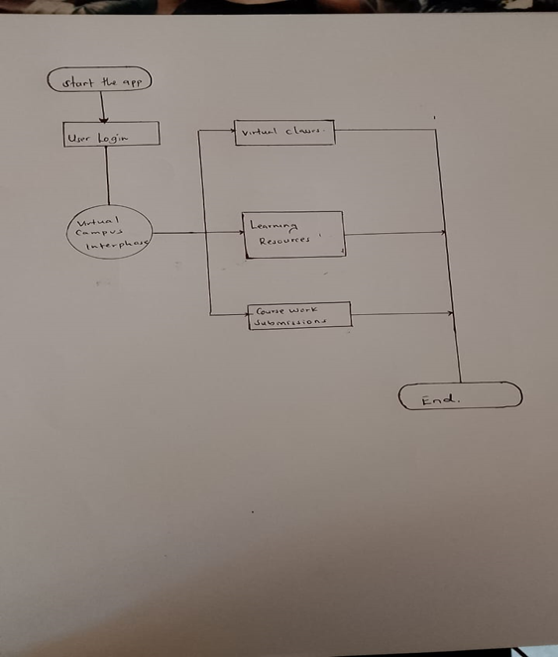

Complaint management system

This module will allow students to lodge, track, and manage complaints efficiently.
Key Features:
- Complaint submission form
- Status tracking and feedback
- Admin dashboard for resolution management
- Analytics and reporting

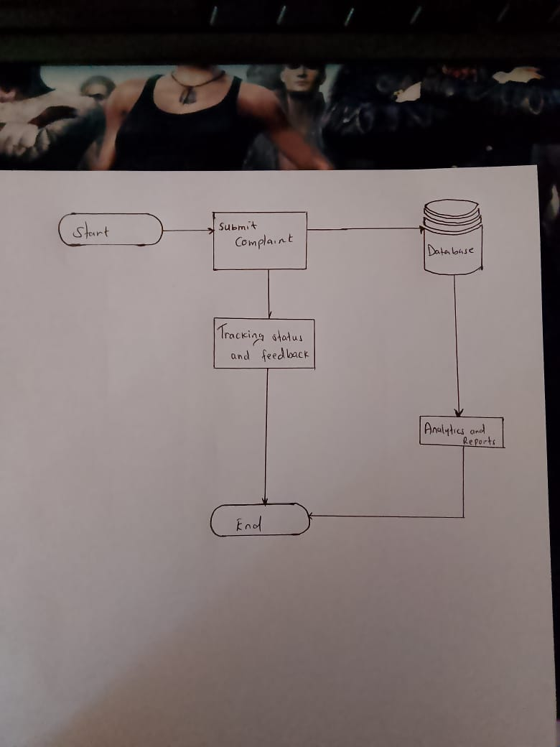

Fee billing and payment system
This feature automates student fee tracking, invoicing, and payment confirmation.
Key Features:
- View fee structures and balances
- Generate electronic receipts
- Integration with M-Pesa API
- Financial reporting for administrators

SYSTEM DESIGN

Database Design
The database model used is relational.
Here are the main tables;
Table | Description
Users | Stores user login credentials and roles
Students | Contains student personal and academic data
Lecturers | Stores lecturer details and subjects taught
Complaints | Tracks student complaints and resolutions
Fees | Contains billing information, payments, and receipts
Courses | Stores course details and codes
Announcements | Manages system-wide notifications

Data Flow Diagram

This is level 0 context diagram
ICMS server
Database
Student / user

Login / requests

Responses / data

Entity Relationship Diagram

STUDENT ----< COMPLAINT >---- ADMIN
| |
| |
+----< FEE BILLING >--------- FINANCE
|
- +----< COURSE >---- LECTURER

User interface Diagram

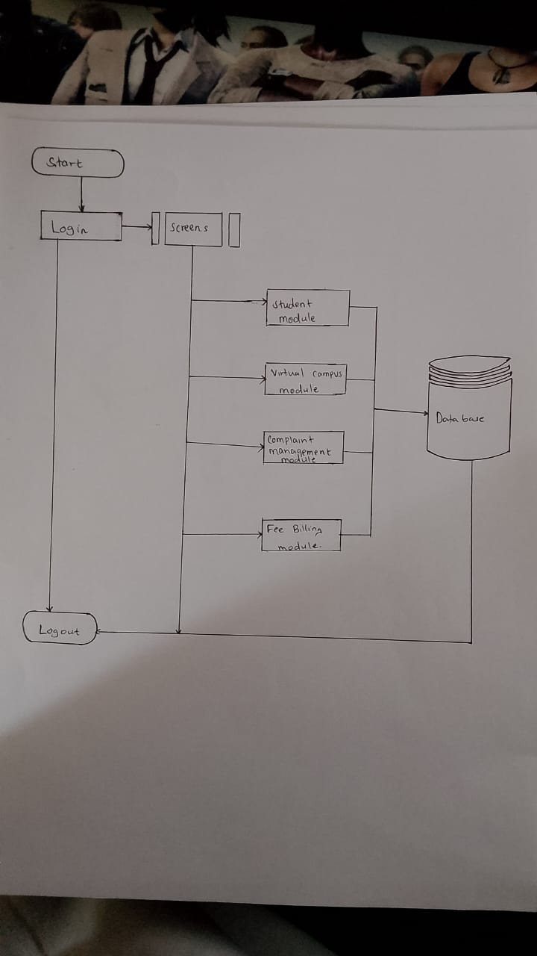

TECHNOLOGY STACK
Technology used for this project are:
- Languages: Java, Kotlin, python
- Frameworks: Django
- Tools: visual studio code, android studio, MySQL

For the database, I used MySQL for the relational and firebase for the non-relational.
During the development phase, I used the codebase in the local storage but for deployment phase, I used the codebase pushed as commits to GitHub.

DEVELOPMENT METHODOLOGY

Agile Methodology
- Requirement Gathering (User views)
Here I conducted a search on how the current students interact with the system in the institution and determine areas that need twitching.
- Sprint planning
Here I break down the entire project into segmented achievable objectives that make it easy to tackle the full project at a slow steady easy pace.
- Development
During this phase I work on the programming part and making the work meaningful and review small increments.
I also adhere to strict time window for achieving each milestone set.
- Testing and review
At the end of each sprint, I conduct a review on each achievement made, I also reflect on the merits and demerits experienced during the development phase.
- Next sprints
Here each sprint builds from the previous ones and by delivering working features at the end of every sprint, I get to see progress in real time and monitor progress early.
- Continuous improvements and deployment

IMPLEMENTATION PLAN

Project Phases
- Project Initiation
Activities:
- Identify project objectives and stakeholders
- Conduct feasibility study (technical, financial, and operational)
- Define project scope and constraints
- Appoint project team and assign roles
Deliverables:
- Project charter
- Feasibility report
- Initial project plan
- System Analysis and Requirements Gathering
Activities:
- Conduct interviews or surveys with users
- Define functional and non-functional requirements
- Develop use case diagrams and user stories
- Create Software Requirements Specification (SRS) document
Deliverables:
- Requirements document (SRS)
- Use case models
- Data flow diagrams

- System Design
Activities:
- Design database structure
- Create system architecture diagrams
- Develop user interface mockups
- Define data models and APIs
Deliverables:
- System Design Specification (SDS)
- UI/UX prototypes
- Database schema

- Implementation (Development)
Activities:
- Set up development environment (e.g., Android Studio)
- Develop front-end and back-end modules
- Integrate database and APIs
- Conduct unit testing on individual modules
Deliverables:
- Source code
- Working application modules
- Unit test reports

- Testing and Quality Assurance

Activities:

- Perform integration testing
- Conduct system and user acceptance testing (UAT)
- Fix bugs and optimize performance
- Validate requirements fulfillment
Deliverables:
- Test plans and test cases
- Bug and defect reports
- Tested software ready for deployment

- Deployment
Activities:
- Prepare deployment environment (server or Play Store)
- Migrate data and perform final configuration
- Deploy the application to production
- Conduct user training if necessary
Deliverables:
- Deployed application
- Deployment and configuration guide
- User manuals

- Maintenance and Evaluation

Activities:

- Monitor system performance and handle user feedback
- Fix post-deployment issues or bugs
- Release patches and updates
- Evaluate project success and document lessons learned
Deliverables:
- Maintenance logs
- Updated software versions
- Final project report

Project Schedule
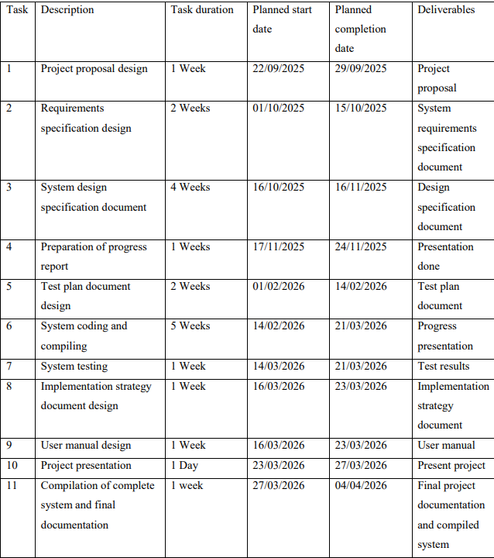

SECURITY AND PRIVACY

Security Measures
- User Authentication and Authorization

The system uses JWT (JSON Web Token) authentication for secure login and session management.
Users must provide valid credentials (email/username and password) before accessing restricted services.
Passwords are never stored in plain text; they are hashed using PBKDF2 or Argon2 via Django’s authentication system.
Role-based access control (RBAC) ensures that users only access resources permitted for their role (e.g., Admin, Customer, or Manager).

- Secure Communication

All communication between the Android client and Django server is transmitted over HTTPS using SSL/TLS encryption.
API endpoints enforce authentication headers to prevent interception or replay attacks.
Sensitive data such as tokens or API keys are stored securely using Android Keystore and never hardcoded in the source code.

- Database Security (MySQL)

The MySQL database is secured with strong credentials and restricted access privileges.
Connections between the Django server and MySQL are established using encrypted SSL connections.
Prepared statements and ORM queries are used to prevent SQL Injection attacks.
Regular database backups and data recovery mechanisms are implemented to ensure data availability.
Data at rest is protected through encryption and hashed identifiers for sensitive information.

- API Security

All API endpoints are protected using token-based authentication and rate limiting to prevent brute-force or denial-of-service attacks.
Input validation and server-side sanitization prevent malicious payloads (e.g., cross-site scripting (XSS) or JSON injection).
APIs are version-controlled and use CORS (Cross-Origin Resource Sharing) settings to limit access only to authorized client origins.
Error messages are sanitized to avoid disclosing system internals.

- Data Validation and Sanitization

All user input is validated both on the Android client and the Django backend to prevent malformed data or code injection.
Special characters, file uploads, and form data are sanitized before database storage.
Validation ensures data integrity and prevents cross-site scripting (XSS) and buffer overflow vulnerabilities.

- Logging and Monitoring

All major system activities, logins, and data transactions are logged for audit purposes.
Logs are secured to prevent tampering and are stored with timestamps and user identifiers.
Automated monitoring tools can detect abnormal behavior such as multiple failed login attempts or suspicious API requests.

- Error Handling and Exception Management

The system implements safe error handling to ensure that error messages do not reveal technical details about the server or database.
All exceptions are caught and logged securely without exposing stack traces to end-users.
User-friendly messages are displayed on the Android application for better experience and security.

- Regular Security Updates

Django and Android dependencies are kept up-to-date to address the latest security vulnerabilities.
Regular security audits and penetration tests are scheduled to identify and fix weaknesses.
The development team adheres to OWASP Mobile and Web Security Guidelines.

Privacy Protection

- Data Minimization

Only essential user information (e.g., name, email, delivery address) is collected.
No unnecessary personal data or sensitive identifiers are requested from users.

- User Consent

The app includes a Privacy Policy that clearly explains data collection, usage, and sharing practices.
Users must explicitly accept permissions before accessing location, storage, or camera services.

- Data Storage and Retention

User data is stored securely on the Django server and MySQL database, not on the Android device.
Personal data is retained only as long as necessary for operational or legal reasons.
Users can request account deletion or data removal in compliance with data protection principles.

- Data Sharing

User data is never sold or shared with third parties without consent.
Any integration with third-party APIs (e.g., payment gateways or Google Maps) follows secure OAuth authentication mechanisms.

- Compliance

The system complies with global privacy standards such as GDPR (General Data Protection Regulation) and Kenya Data Protection Act 2019.
Privacy settings are transparent and user-controlled.

TESTING STRATEGY

The types of testing strategies implemented are:
- Functional Testing
Ensures that each function of the system operates according to requirements.
- Performance Testing
Measures the responsiveness and stability of the application under load.
Tools: Apache JMeter, Locust, or Django’s testserver stress testing.
Objectives:
    - Verify API response times (< 2 seconds per request).
    - Evaluate server scalability under concurrent user load.
- Security Testing
Ensures the system is protected against unauthorized access and data breaches.
Tests include:
    - Authentication and authorization checks (JWT token validation).
    - SQL Injection and XSS attack prevention.
    - Encrypted communication (HTTPS).
Tools: OWASP ZAP, Burp Suite.

- Compatibility Testing
Ensures the app runs consistently across different devices, OS versions, and screen sizes.
Tools: Android Studio Emulator, Firebase Test Lab.
Test Scenarios:
    - Android 10 → Android 15 devices
    - Phones and tablets with varied resolutions

- Regression Testing
Conducted after each update or bug fix to ensure existing functionality is not broken.
Tools: Jenkins for CI/CD test automation.

- Database Testing
Validates MySQL data integrity and backend consistency.
Focus:
    - Schema validation
    - Data relationships and foreign key constraints
    - Query performance and transaction rollback

MAINTENANCE AND SUPPORT

Types of Maintenance to be used:

- Corrective Maintenance
Focuses on identifying and fixing bugs or errors that occur during system operation.

- Adaptive Maintenance
Involves modifying the system to accommodate changes in the operating environment, technologies, or regulatory requirements.

- Perfective Maintenance
Aims to enhance system performance or add minor improvements based on user feedback.

- Preventive Maintenance
Includes proactive measures to prevent future system failures or performance issues.

Support Structure
- Technical Support
A dedicated support team will assist users and administrators in handling technical issues related to:
- Installation and configuration
- API integration or communication errors
- Database access and synchronization
- Application updates and compatibility

- User Support
End-users are provided with:

- User manuals and FAQs within the app or website.
- Tutorial videos or guides for first-time users.
- Periodic notifications about new updates or features.

BUDGET AND RESOURCES
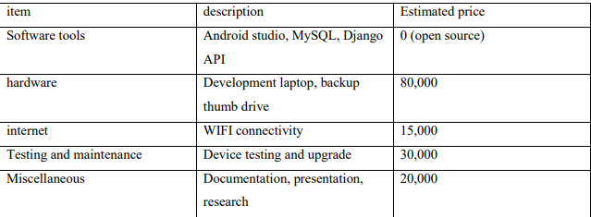

CONCLUSION
The proposed Integrated Campus Management System will enhance service delivery and digital interaction here at KCA University. By combining academic, administrative, and financial operations into one seamless platform, the system will reduce manual workload, enhance transparency, and improve student satisfaction. Once implemented, it will position KCA University as a model of technological advancement and digital transformation in higher education category

REFERENCES

- University of Nairobi ICT Department. (2022). Student Portal Development and Impact Study.
- Makerere University ICT Directorate. (2021). Digital Complaint System Evaluation.
- Sommerville, I. (2020). Software Engineering (10th Edition). Pearson Education.
- Pressman, R. S. (2019). Software Engineering: A Practitioner’s Approach. McGraw-Hill

